Injection Documentation

Prior to Administering the Vaccine:
- Verify the patient and the label per the Deltoid Injection Training Presentation and Medication Administration policies.
- Go over the appropriate consent forms and any other vaccine education materials with the patient and have them sign prior to preparing the vaccine.

**Note: Universal Vaccine Consent Form with RSV link HERE!**

- Open the patient’s chart in the room and verify you have the correct patient.
- Begin documentation by opening a blank Note.
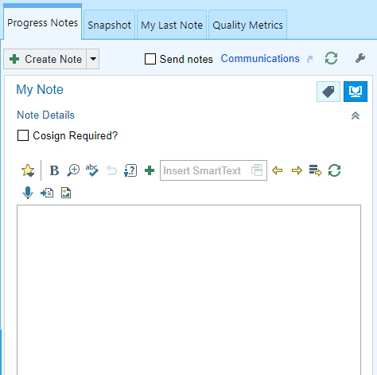

  - If a provider already has a note, create a new blank note by clicking the Create Note button.

**Tip: You can make the Injection Documentation SmartPhrase into a speed button for easier use in a future visit. Click HERE for the steps.**

- In the blank Note type .WHAHPIINJECTIONDOCUMENTATION.
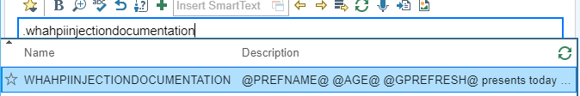

- Ensure a full set of vitals have been documented - including a respiratory reading.
- Verify the injection to be administered with the patient, letting them visualize the vaccine to be administered.
- Using the Injection Type smartlist, double-click the appropriate selection.
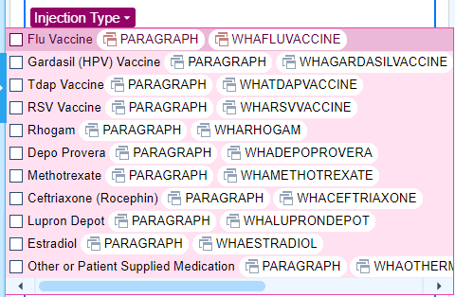
- The selections in the list will guide you on what should be completed prior to administering the injection, such as screening questions, tracking, and whether the patient needs to be observed post-administration.
- Verify an order is in place for the vaccine.

**Note: If an order has not been placed, you will need to get a verbal order from the provider prior to signing an order and administering the vaccine to the patient.**

Ordering the Vaccine:

For OB Patients
A section has been added to the OB RETURN VISIT SmartSets that allows vaccine orders to be placed during an OB visit.
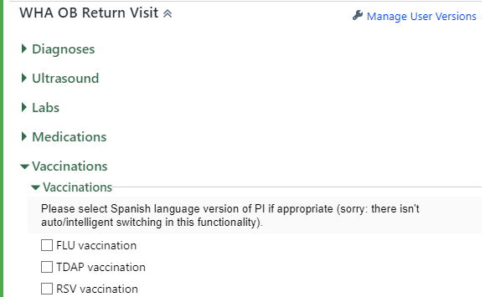

When the order is selected, it will attach the appropriate diagnosis code and patient education materials.
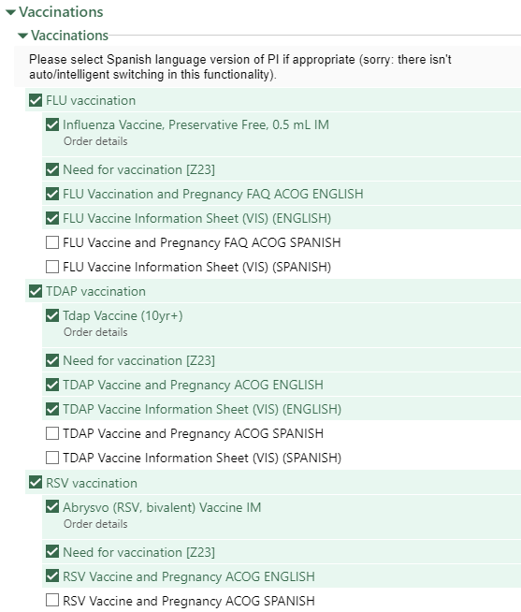

For GYN Patients
You will only want to place an order once you’ve obtained a verbal order from your provider. Do not place an order prior to discussing it with the patient’s responsible provider first.

- Open the Preference List .
- Click the Immunizations category.
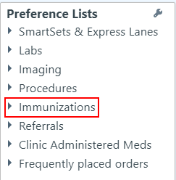

- Select the appropriate immunization order.
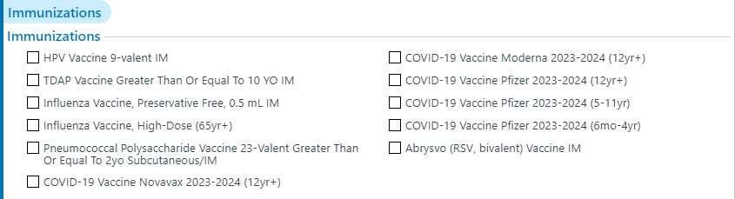

- Click Accept .
- Click Dx Association.
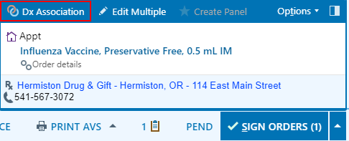
- Search for Need for vaccination.
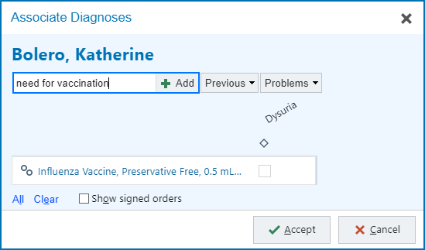

- Double click Need for vaccination.
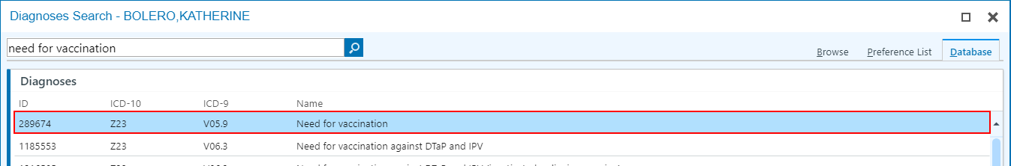

- Check the box to associate this diagnosis code with the order.
- Click Accept.
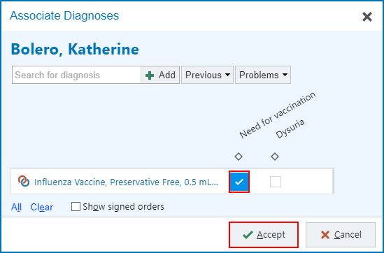

- Click Sign Orders.
  - You can also utilize Selective Sign if multiple orders are present, but you only need to sign off the immunization order.
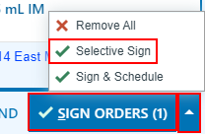

- Once an order has been signed, click the Immunizations 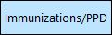 activity.

**Note: If you have not previously wrenched in this activity, it will be in the Additional Activities drop down arrow. You can star it for future ease of use.**
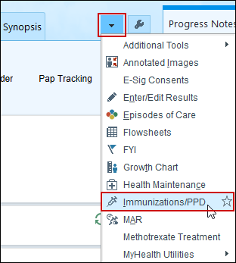

- Click Administer
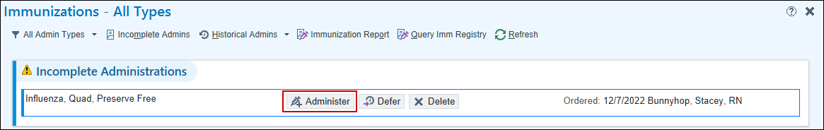
- BEFORE you administer the vaccine, you will need to enter the required information:
  - Lot #, Manufacturer, NDC, Expiration Date.
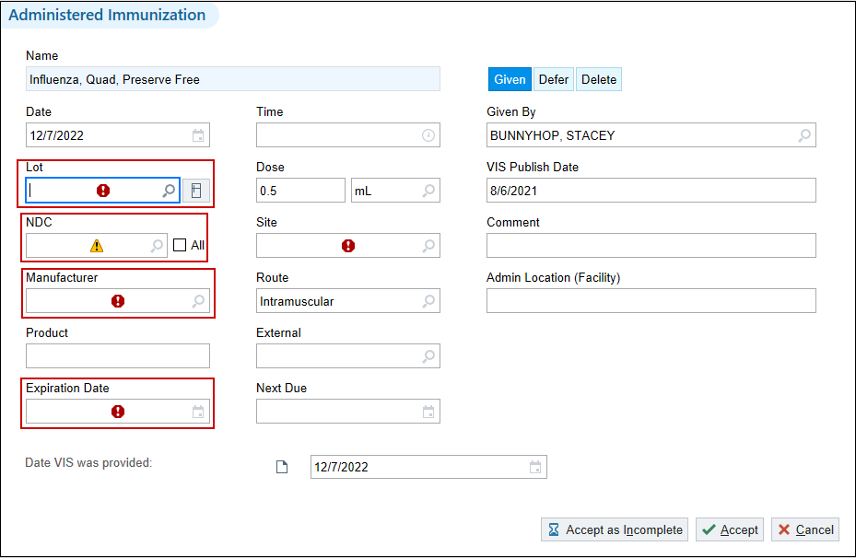

Documenting Administration of a Vaccine
- After using the appropriate landmarking technique, administer vaccine.
  - Document the Time of immunization, Site of injection, and the date the VIS was given to the patient
Link to VIS in different languages

- Enter the time and site then click Accept
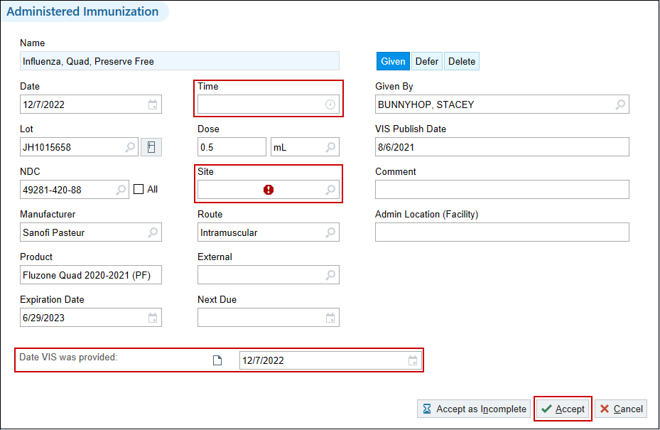

- To view the recent administration, click the chevron in Administration History.
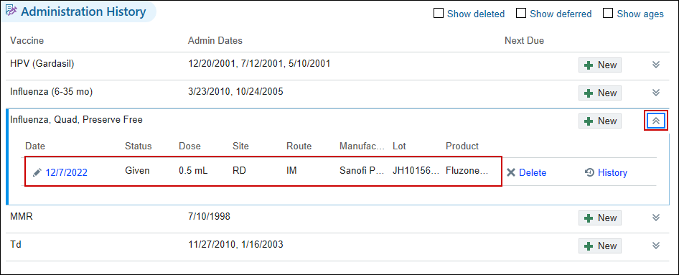
  - To edit the administration, click the vaccine name (it’s an expanding section)
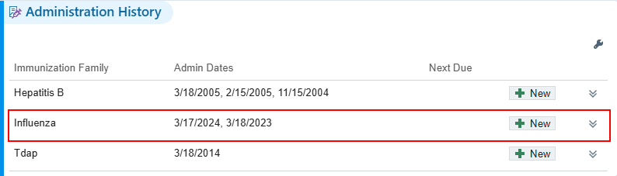
  - Then, click the date that needs to be edited (a hyperlink).
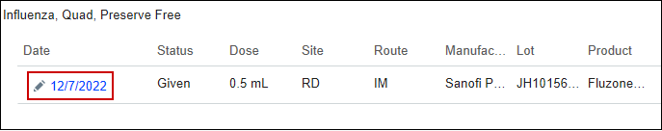
  - This will reopen the administration page, change what needs to be changed, then click Accept once complete.

- Go back to the note you created and complete any necessary documentation.
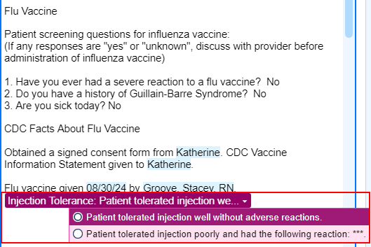

- Click Accept to save the note.

**Note: If you are documenting under an injection or nurse visit type sign the visit after completing documentation.**

Documenting Administration of a Medication
- BEFORE you administer the vaccine, you will need to enter the required information in the Medication Administration Record (MAR):
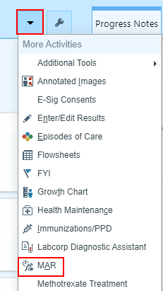
  - Lot #, NDC, Expiration Date.
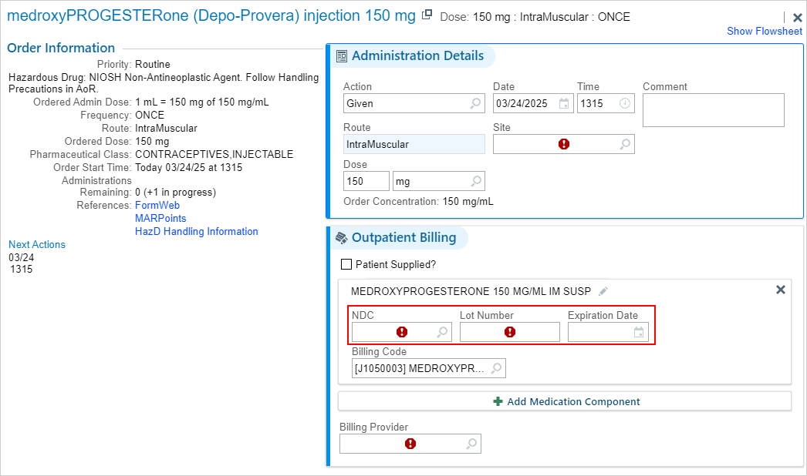
- After using the appropriate landmarking technique, administer vaccine.
  - Document the Time of immunization and Site of injection.
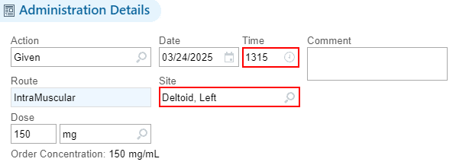
- Click Accept

